ASR 5279 ITS and Pick ticket Fotenote check List changes:

Request: 21 Apr 2015

Amendments in Inbound/Outbound sheets

1. The inbound tally sheet needs to have additional two items: Cleanliness and security

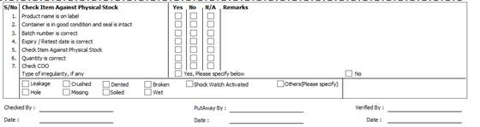

1. Same for Outbound. It is required to have a check for Cleanliness and Security

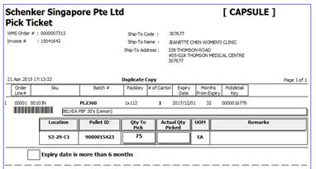

**Revised Changes: [2015.05.05]**

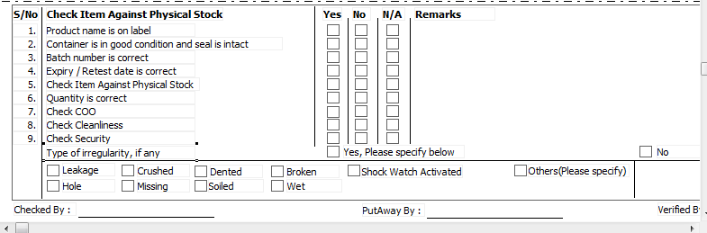

Point 5 = Pls remove

Point 8 = Pls put as “Outer carton is clean and dry”

Point 9 = Pls put as “Carton is not retaped at top and base”

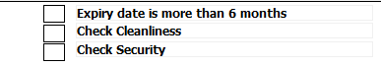“Check Cleanliness” change to “**Product is clean and dry**”

“Check Security” change to “**Carton is taped and sealed**”

WMS UPDATE:

Changes Apply to Storer – SIGMA and CAPSULE

